344C5
Popa Iulia

Laboratory 8 - I/O Monitoring (Windows)

Task 01. Task Manager

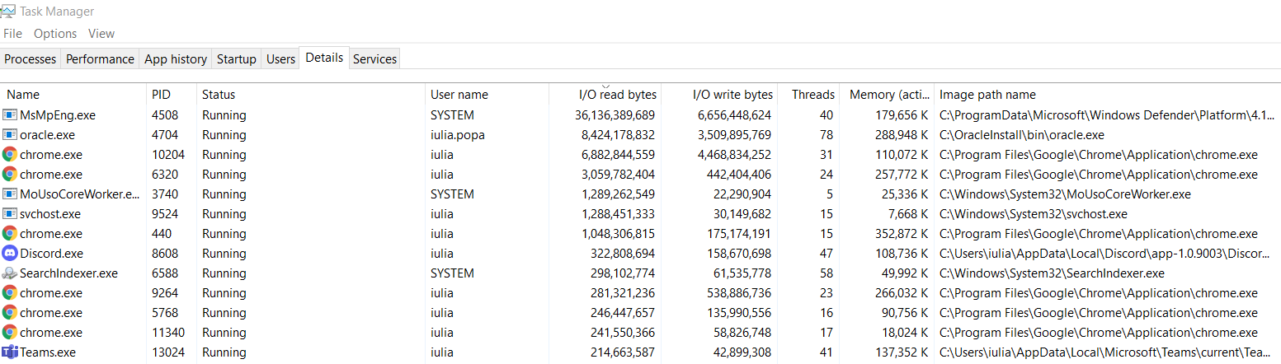
Better view:

MsMpEng.exe is the core process of the Windows Defender Antimalware Application. The reason why it is constantly reading/writing to my hard disk is that the executable process actively runs in the background, scans files, connections and other programs to provide protection.

Task 02. Windows Performance Recorder & Analyzer

WPA Analysis for Storage:
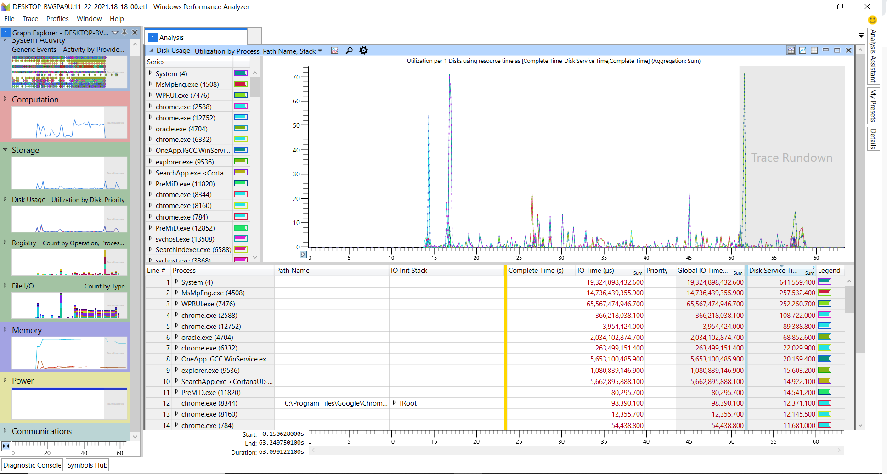

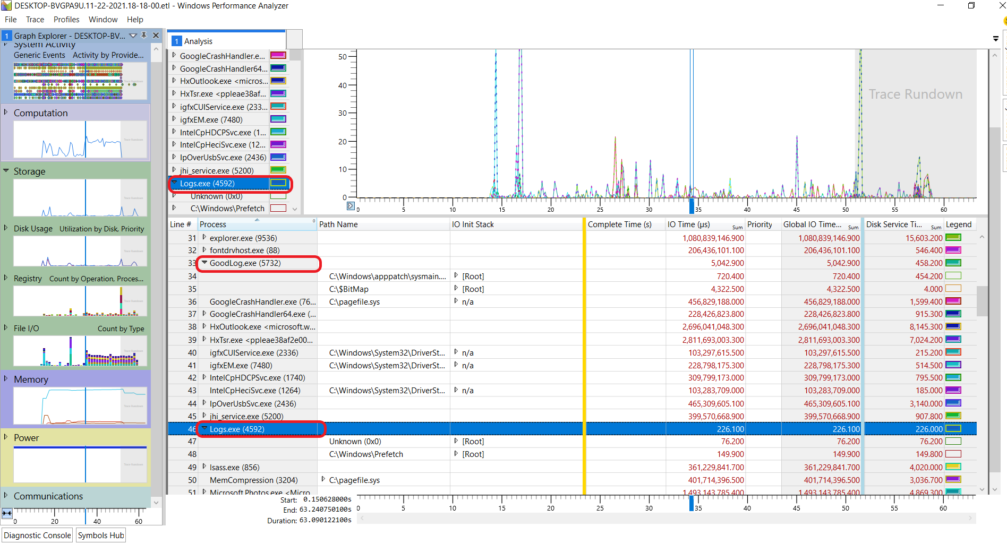

Task Manager:
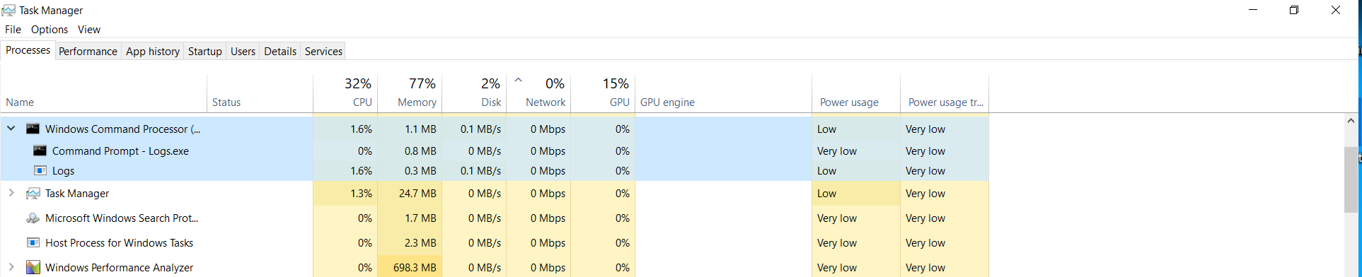
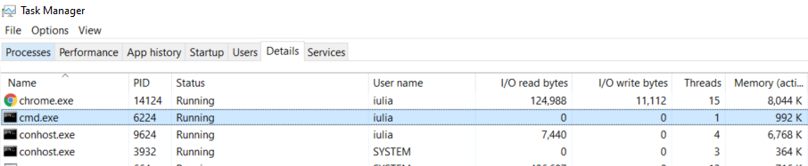

Task 03. Process Monitor
- Checking Logging File
Logs.exe:

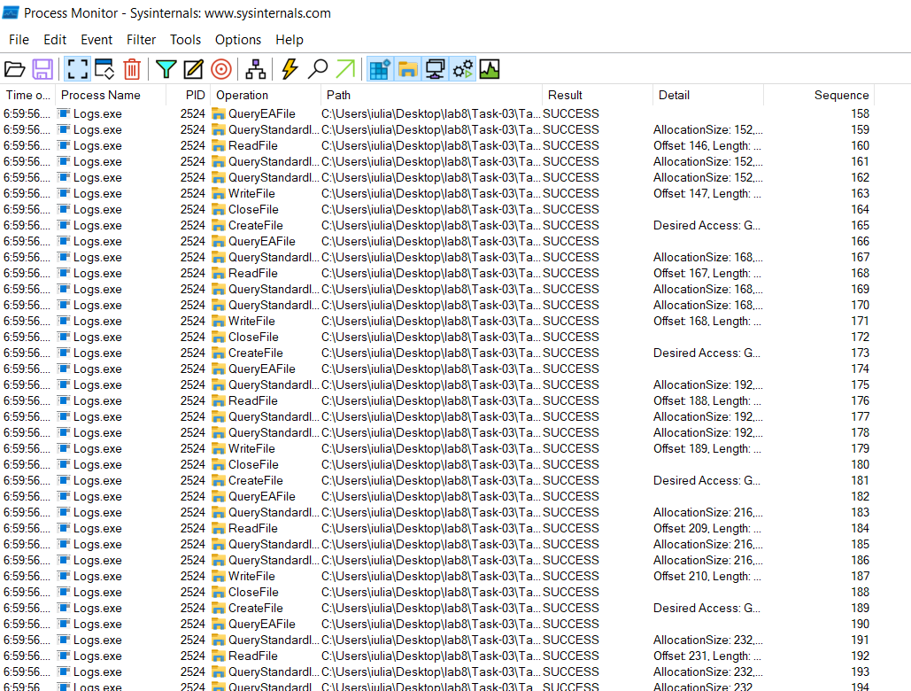

GoodLog.exe: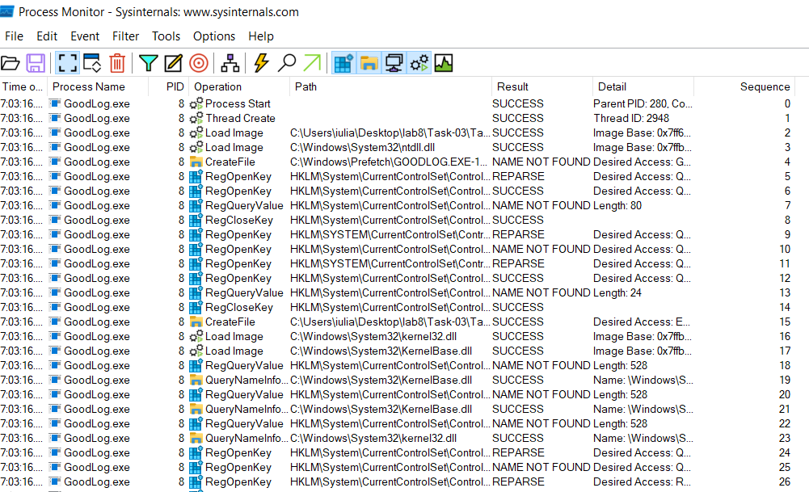

Logs.exe versus GoodLog.exe:
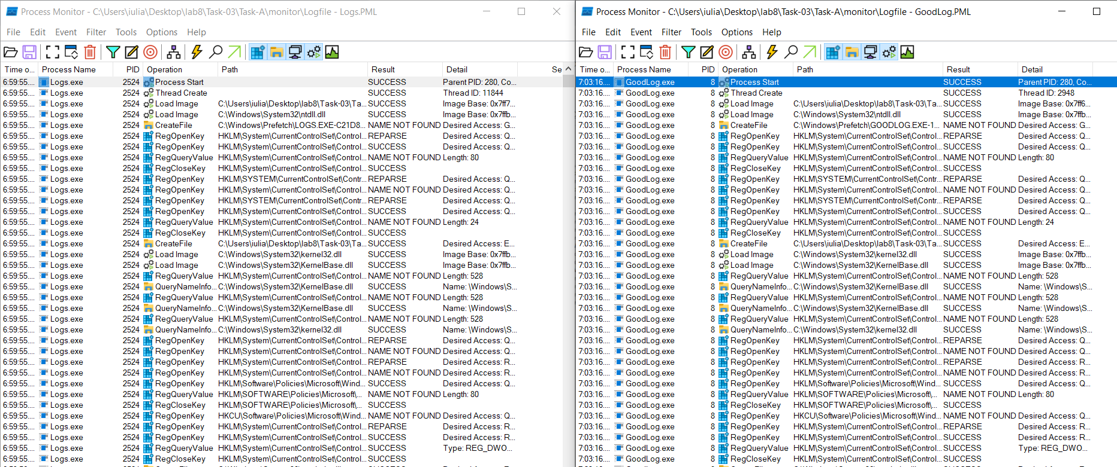
Logs.exe creates a file, then makes a read and a write, and after all closes the file, doing this on repeat. Meanwhile, GoodLog.exe creates it, writes multiple times, and then closes the file at the end.

- Investigating a Handle Leak

Good.exe versus Bad.exe
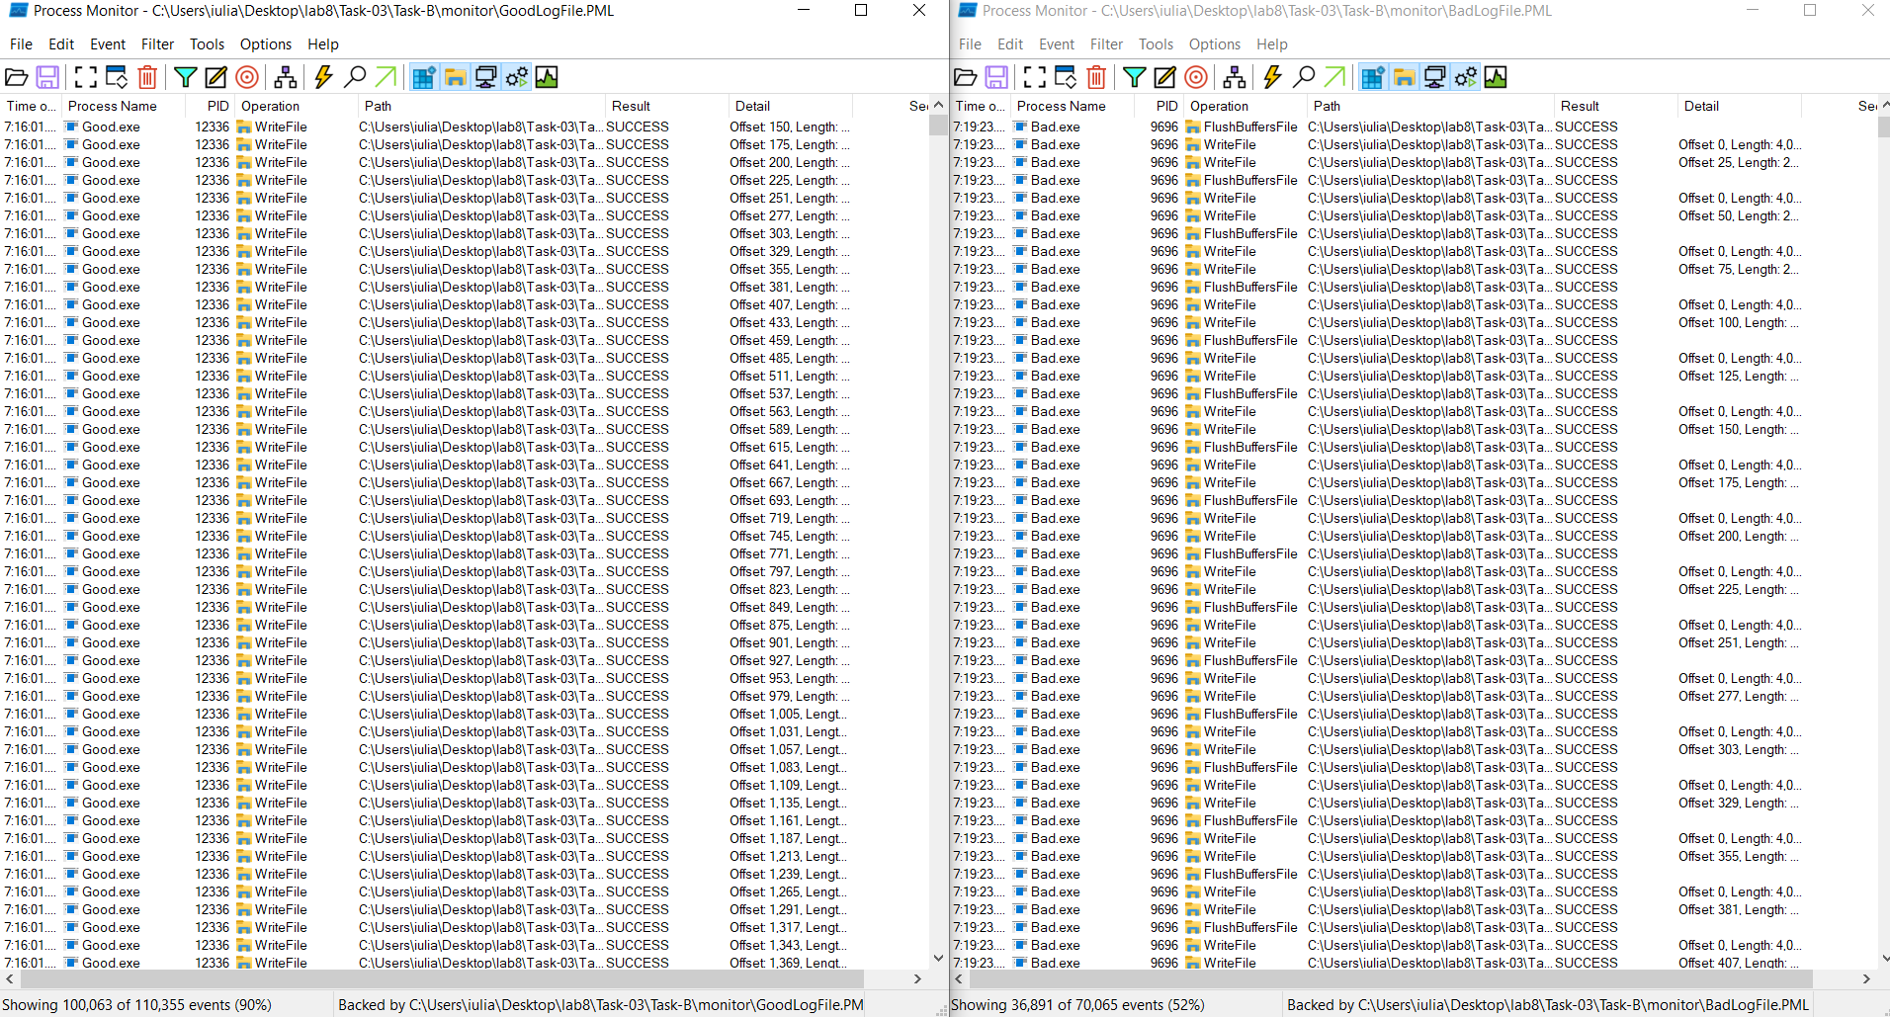

Bad.exe calls the FlushBuffersFile command every two write calls, while Good.exe writes continuously. The problem though might be the open handler.
Task Manager:
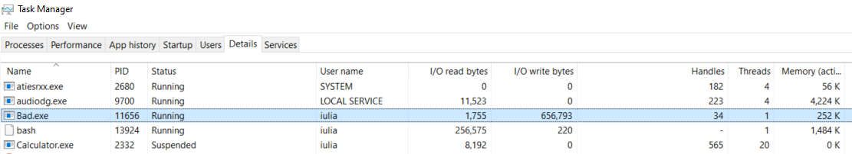

Task 04. Process Explorer

HandleLeak.exe in Process Explorer:
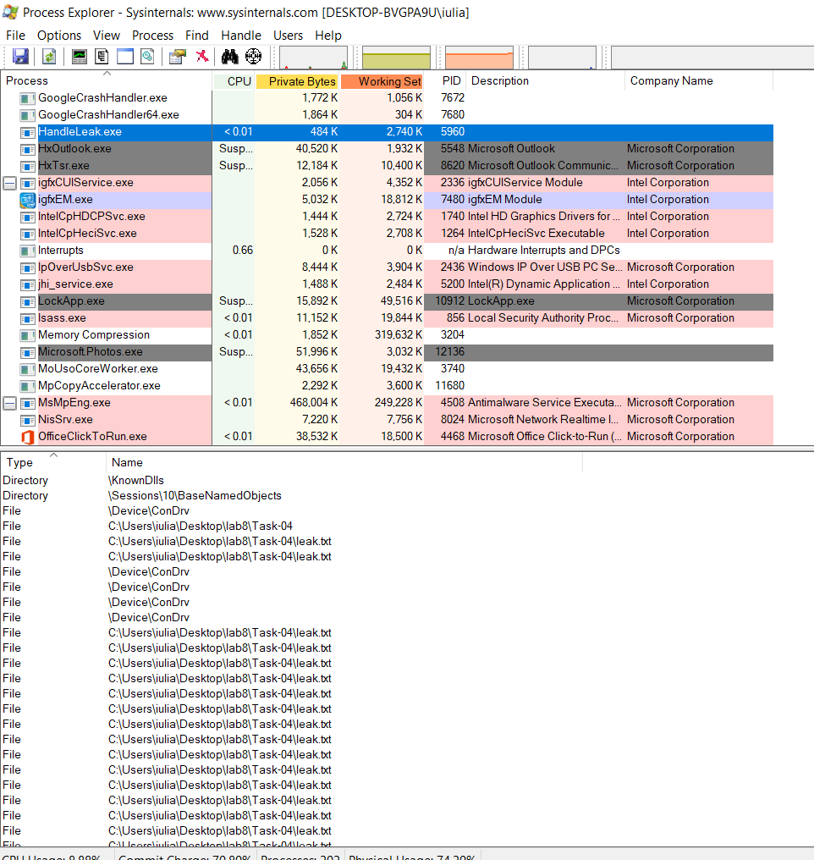

HandleLeak.exe in Process Monitor:
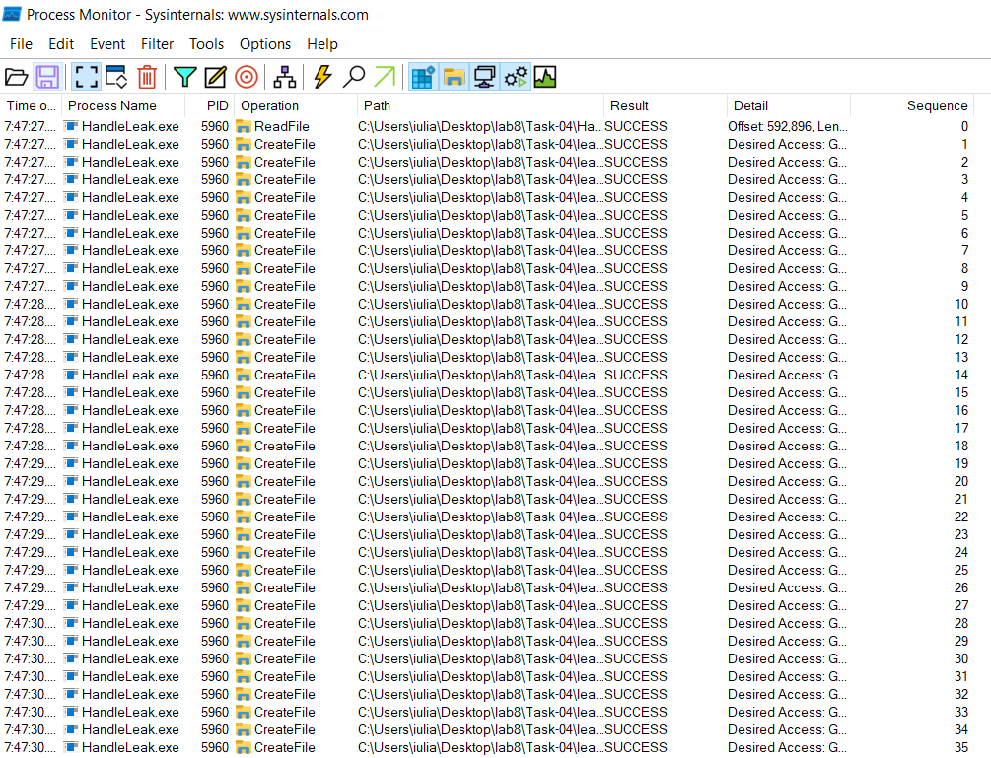
Problem is that HandleLeak.exe continuously creates handlers without closing the last one created.

HandleLeak.exe in Task Manager:
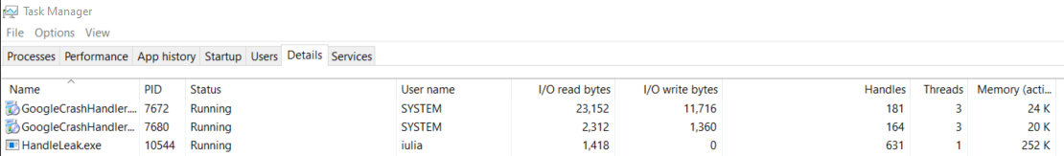

Task 05. Windows API

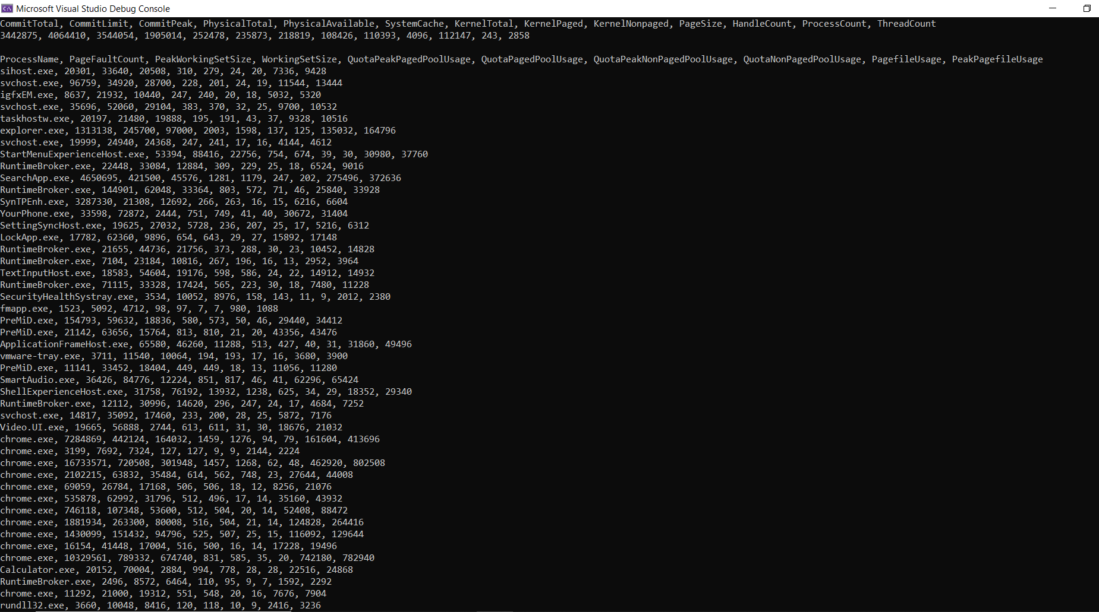
As the Romanian people say: “Hai ca se vede daca e!” or “Mergem pe incredere!”...
Added the code in the archive.

Tadam! 🎉🎉🎉🎉🎉🎉🎉🎉


